Assignment No 1



Spring 2025

**CSE-408 Digital Image Processing**

Submitted by: MUHAMMAD SADEEQ

Registration No.: 21PWCSE2028

Section: C

“On my honor, as a student of the University of Engineering and Technology, I have neither given nor received unauthorized assistance on this academic work”

Submitted to:

Engr. Mehran Ahmad

(20 May 2025)

Department of Computer systems engineering

University of Engineering and Technology, Peshawar

**Activity 1**

**Code:**

% Read the original image

originalImage = imread('cameraman.tif');

figure;

imshow(originalImage);

title('Original Image');

% Convert to grayscale if the image is RGB

if size(originalImage, 3) == 3

grayImage = rgb2gray(originalImage);

else

grayImage = originalImage;

end

% Define a threshold value (0 to 255 for uint8 images)

thresholdValue = 100;

% Apply thresholding

binaryImage = grayImage > thresholdValue;

% Display the thresholded image

figure;

imshow(binaryImage);

title(['Thresholded Image (Threshold = ', num2str(thresholdValue), ')']);

**Output:**

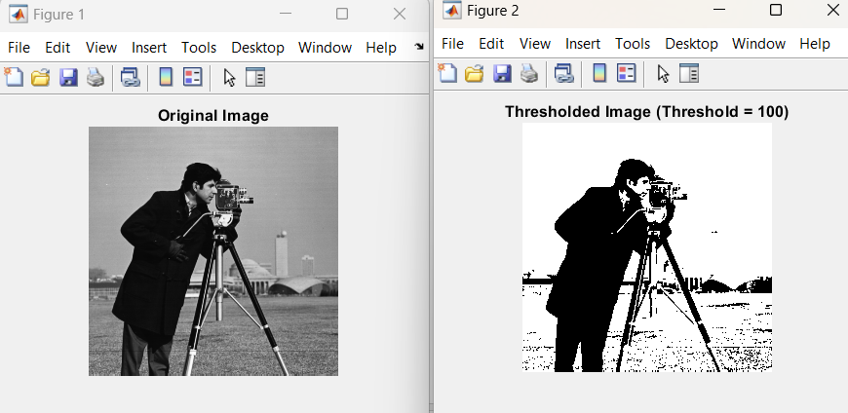

**Activity 2**

**Code:**

% Read the original image

originalImage = imread('cameraman.tif');

% Convert to grayscale if it's RGB

if size(originalImage, 3) == 3

grayImage = rgb2gray(originalImage);

else

grayImage = originalImage;

end

% Negative transformation

negativeImage = 255 - grayImage;

% Display original and negative images

figure;

subplot(2, 2, 1);

imshow(grayImage);

title('Original Image');

subplot(2, 2, 2);

imshow(negativeImage);

title('Negative Image');

% Plot histograms

subplot(2, 2, 3);

imhist(grayImage);

title('Histogram of Original Image');

subplot(2, 2, 4);

imhist(negativeImage);

title('Histogram of Negative Image');

**Output:**

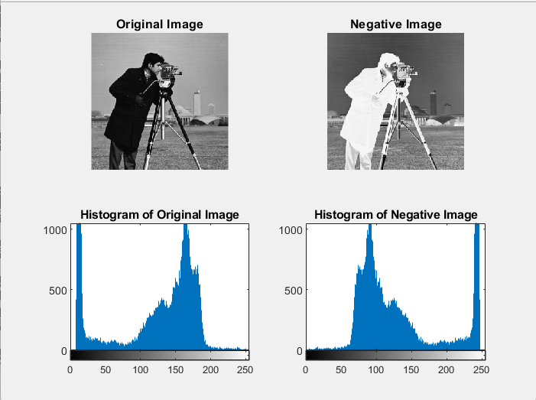

**Activity 3**

**Code:**

% Read the original image

originalImage = imread('cameraman.tif');

% Convert to grayscale if it's RGB

if size(originalImage, 3) == 3

grayImage = rgb2gray(originalImage);

else

grayImage = originalImage;

end

% Convert image to double for log transformation

doubleImage = im2double(grayImage);

% Apply log transformation

c = 1; % Scaling constant (can adjust to enhance effect)

logImage = c * log(1 + doubleImage);

% Normalize to 0-1 for display

logImage = mat2gray(logImage);

% Display original and log-transformed image

figure;

subplot(1, 2, 1);

imshow(grayImage);

title('Original Image');

subplot(1, 2, 2);

imshow(logImage);

title('Log-Transformed Image');

**Output:**

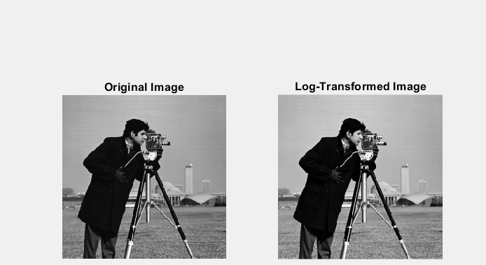

**Activity 4**

**Code:**

% Read the original image

originalImage = imread('cameraman.tif');

% Convert to grayscale if it's RGB

if size(originalImage, 3) == 3

grayImage = rgb2gray(originalImage);

else

grayImage = originalImage;

end

% Convert to double and normalize (0 to 1)

doubleImage = im2double(grayImage);

% Define gamma values to test

gammaValues = [0.4, 0.7, 1.0, 1.5, 2.5];

% Create figure for original and transformed images

figure;

% Show original image

subplot(2, ceil((length(gammaValues) + 1)/2), 1);

imshow(grayImage);

title('Original Image');

% Apply power-law transformation for each gamma

for i = 1:length(gammaValues)

gamma = gammaValues(i);

transformedImage = doubleImage .^ gamma;

% Normalize and convert to image format

transformedImage = mat2gray(transformedImage);

% Display the transformed image

subplot(2, ceil((length(gammaValues) + 1)/2), i + 1);

imshow(transformedImage);

title(['\gamma = ', num2str(gamma)]);

end

**Output:**

